##### 747 ­

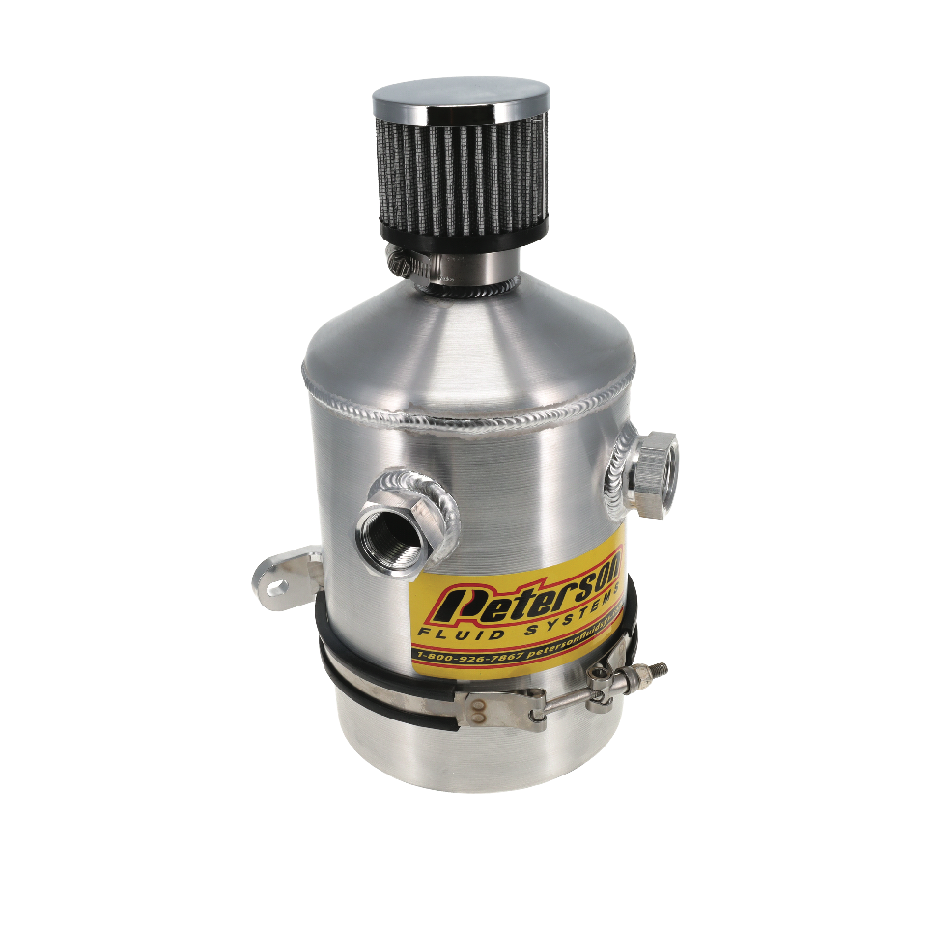

MaY 1, 2023

Press Release/New Product

**1 GALLON BREATHER CAN**

**Part No. 08-0406**

Peterson's high volume catch can (aprox. 1 gallon) is ideal for long races or high boost applications plumbed with burn down tubes. Whether you have a high performance boat, off-road, endurance racecar, or compete in drag and drive, this premium breather can is designed for you. Fabricated in our facility in Colorado, this can is internally baffled and has a breather filter element. It comes standard with two -12 AN port fittings to plumb -16 AN or -12 AN lines, a drain plug and a mounting bracket.

|  |  |  |
| --- | --- | --- |
| **Part #** | **Racer** | **List** |
| **08­-0406** | **489.99** | **612.49** |

All pricing in US Dollars • ©2023 Niwot Corp. dba Specialty Products Company®

*4045 Specialty Place • Longmont, CO 80504 • 800-929-7867 • 303-287-1731 • www.petersonfluidsys.com*

**SSAVE OVER**

50%