##### 747 ­

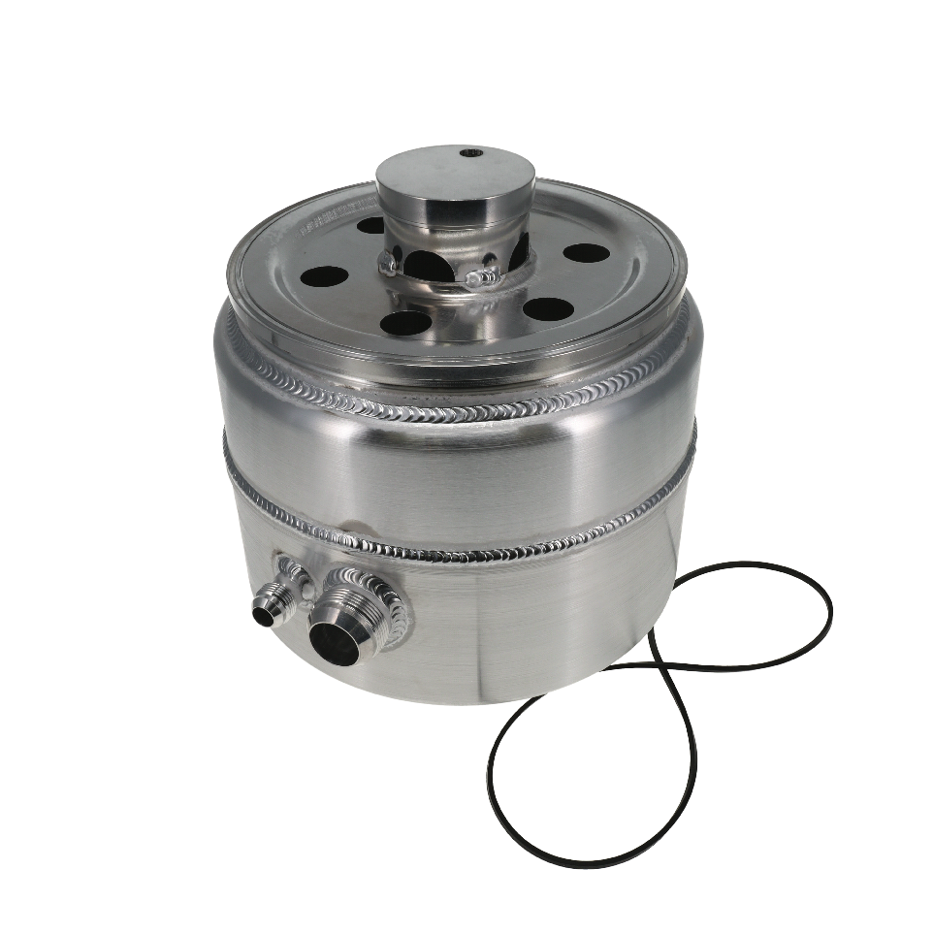

**#08-9099-20**

**#08-9099**

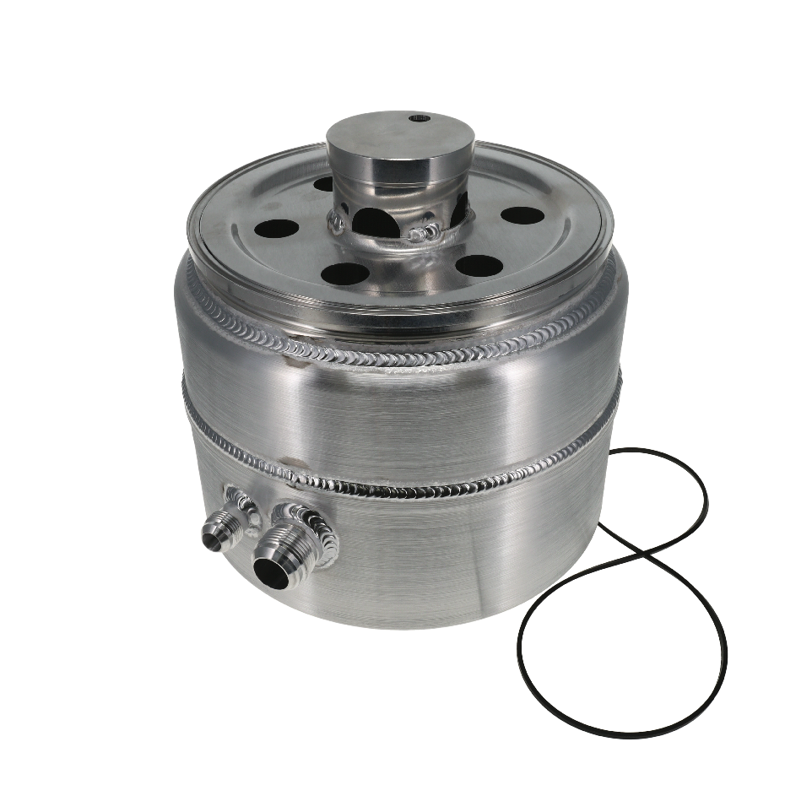

|  |
| --- |
| **Pricing** |
| **For current pricing contact Peterson Fluids Systems at**[**pfsinfo@specprod.com**](mailto:pfsinfo@specprod.com)**or 800-929-7867** |

June 4, 2024

Press Release/New Product

**FAT BOY DLM OIL TANK RETROFIT KITS**

**Part No. 08-9099 / 08-9099-20**

Maximize oil capacity with existing equipment in space restricted locations using this retrofit kit. Convert an existing Peterson 4 or 5 gallon Dirt Late Model (DLM) oil tank into the new “Fat Boy” style tank. Features include new bottom section, lower baffle assembly and tank gasket. Mounting brackets are sold separately. Part number 08-2105 includes two 10.5” straps with panel mount and #08-2108 includes one 9.0” and one 10.5” for 1.5” chassis bar applications.

3D models available upon request.

**Key Features:**

• 4 or 5 Gallon capacity retrofit to standard DLM tanks

• All Aluminum construction

• Tank heater bung

• Oil System Primer Fitting

• 3” shorter than standard 4 or 5 gallon DLM tank

• Take apart design for easy cleaning

• Gasket & Baffle included

All pricing in US Dollars • ©2024 Niwot Corp. dba Specialty Products Company®

*4045 Specialty Place • Longmont, CO 80504 • 800-929-7867 • 303-287-1731 • www.petersonfluidsys.com*

**SSAVE OVER**

50%