##### 747

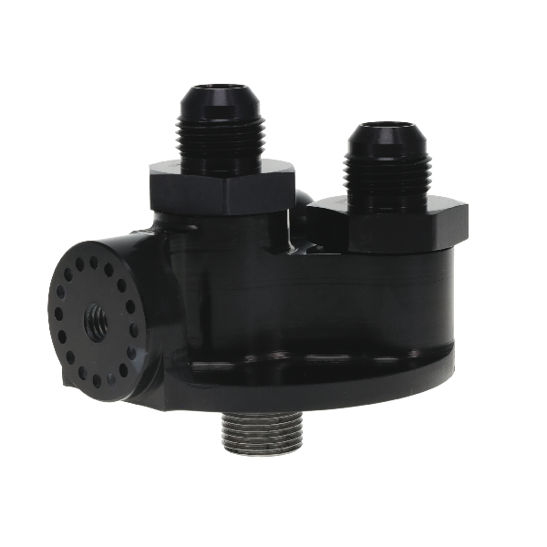

All pricing in US Dollars • ©2022 Niwot Corp. dba Specialty Products Company®

**REMOTE FILTER MOUNT AVAILABLE BRACKETS**

**Part No. 09-1590, 09-1591, 19-1592, 09-1593, 09-1594, 09-1595, 09-1584, 08-2206, 08-2207, 08-2209**

|  |  |  |  |  |
| --- | --- | --- | --- | --- |
| **Part #** | **Thread** | **Fittings** | **Jobber** | **List** |
| **09-1390** | **13/16-16** | **-10 AN** | **199.95** | **249.94** |
| **09-1391** | **13/16-16** | **-12 AN** | **199.95** | **249.94** |
| **09-1392** | **3/4-16** | **-10 AN** | **199.95** | **249.94** |
| **09-1393** | **3/4-16** | **-12 AN** | **199.95** | **249.94** |
| **09-1394** | **1 1/2-12** | **-10 AN** | **209.95** | **262.44** |
| **09-1395** | **1 1/2-12** | **-12 AN** | **209.95** | **262.44** |
| **09-1396** | **1 1/2-16** | **-10 AN** | **209.95** | **262.44** |
| **09-1397** | **1 1/2-16** | **-12 AN** | **209.95** | **262.44** |
| **09-1398** | **System 1** | **-10 AN** | **199.95** | **249.94** |
| **09-1399** | **System 1** | **-12 AN** | **199.95** | **249.94** |

November 15, 2022

Press Release/New Product

**REMOTE FILTER MOUNT**

**Part No. 09-1390/91/92/93/94/95/96/97/98/99**

Peterson's remote filter mounts are CNC machined from 6061 - T6 aluminum and black anodized. Ports are designed for free flow of oil and come with -10 or -12 AN fittings. Features include an 1/8" NPT port for a gauge or turbo feed line and a versatile mounting system which allows the filter to be placed anywhere desired. (Mount bracket sold separately.) Made in the USA since 1976, these parts are produced in our machine shop in Longmont Colorado.

d

*4045 Specialty Place • Longmont, CO 80504 • 800-929-7867 • 303-287-1731 • www.petersonfluidsys.com*

**SSAVE OVER**

50%