##### 747

|  |  |  |  |
| --- | --- | --- | --- |
| **Part #** | **Thread** | **Jobber** | **List** |
| **09-1508** | **13/16”-16** | **99.95** | **124.94** |

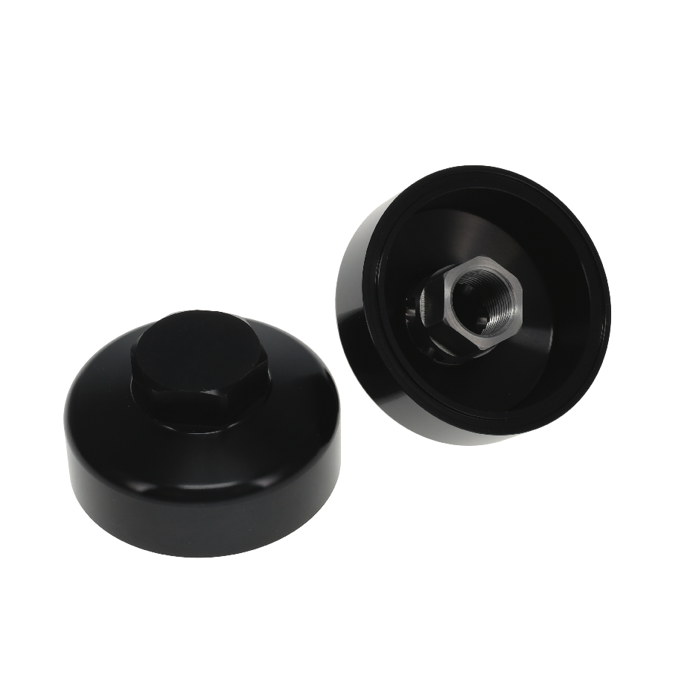

All pricing in US Dollars • ©2023 Niwot Corp. dba Specialty Products Company®

January 10, 2022

Press Release/New Product

**SMALL PRIMER BYPASS**

**Part No. 09-1508**

Peterson's small primer bypass is CNC machined from 6061 - T6 aluminum and black anodized. Use this bypass filter adapter to make your remote primer compatable with aftermarket filtration systems. This unit is threaded for filter post size 13/16” - 16 thread. Made in the USA since 1976, these parts are produced in our machine shop in Longmont Colorado.

*4045 Specialty Place • Longmont, CO 80504 • 800-929-7867 • 303-287-1731 • www.petersonfluidsys.com*

**SSAVE OVER**

50%