##### 747 ­

|  |
| --- |
| **Pricing** |
| **For current pricing contact Peterson Fluids Systems at**[**pfsinfo@specprod.com**](mailto:pfsinfo@specprod.com)**or 800-929-7867** |

January 16, 2024

Press Release/New Product

**LSX OIL PUMP MOUNTING BRACKETS**

**Part No. 14-3105 / 14-3106**

Mount Peterson’s R4 Oil Pump on your LSX engine

with these 6061 billet machined mount blade brackets. These right side or left side mounting systems facilitate forward or rearward pump placement to aline with drive pulley and integrate tensioning for belt. Kits include all necessary hardware for mounting your oil pump to the engine block. Brackets are compatible with factory and most LSX casting variants. 3D models available upon request.

**Key Features:**

• Accommodate various pump depth options

• All mounting hardware included

• Machined Billet 6061 T6 Aluminum construction

• Integrated belt tensioning

• Fits most popular LSX variants, to include GM, Noonan and Dart

• Made in USA

**14-3106 Right Side**

**14-3105 Left Side**

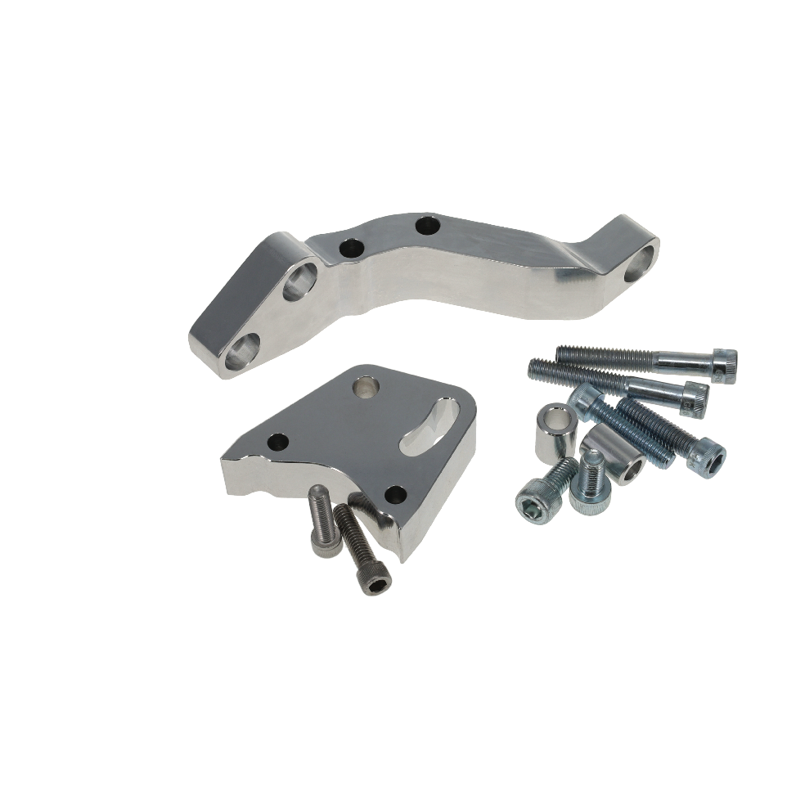

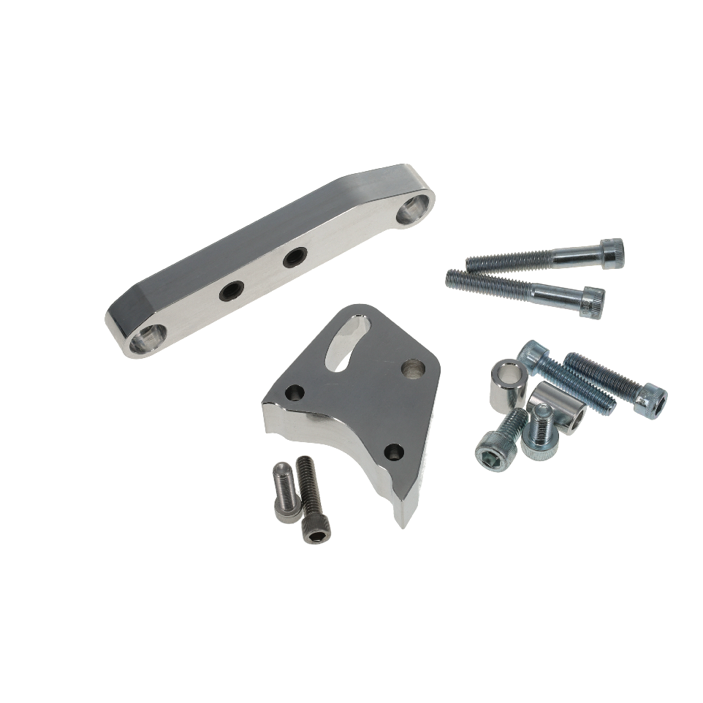

All pricing in US Dollars • ©2024 Niwot Corp. dba Specialty Products Company®

*4045 Specialty Place • Longmont, CO 80504 • 800-929-7867 • 303-287-1731 • www.petersonfluidsys.com*

**SSAVE OVER**

50%