##### 747 ­

August 26, 2024

Press Release/New Product

**COYOTE R4 OIL PUMP MOUNT**

**Part No. 14-3112**

Upgrade the Coyote engine's factory oil system with a Peterson Fluid System R4 oil pump. Utilizing the A/C compressor's mounting holes, this Coyote engine specific mount kit will allow you to place a two (2) to six (6) stage R4 oil pump on the right side of the block. Peterson's oil pump mounting systems are machined in-house from 6061 T-6 billet aluminum for strength and reduced weight. Kit includes two mount blades, block adapter, and all necessary hardware. This flexible system will allow positioning of the drive pulley forward of the balancer or behind depending on build needs. CAD models are also available to aid in system layout design.

**Key Features:**

• Accommodate various pump depth options

• All mounting hardware included

• Machined Billet 6061 T6 Aluminum construction

• Integrated belt tensioning

• Designed specifically for the Ford Coyote engine

• Made in USA

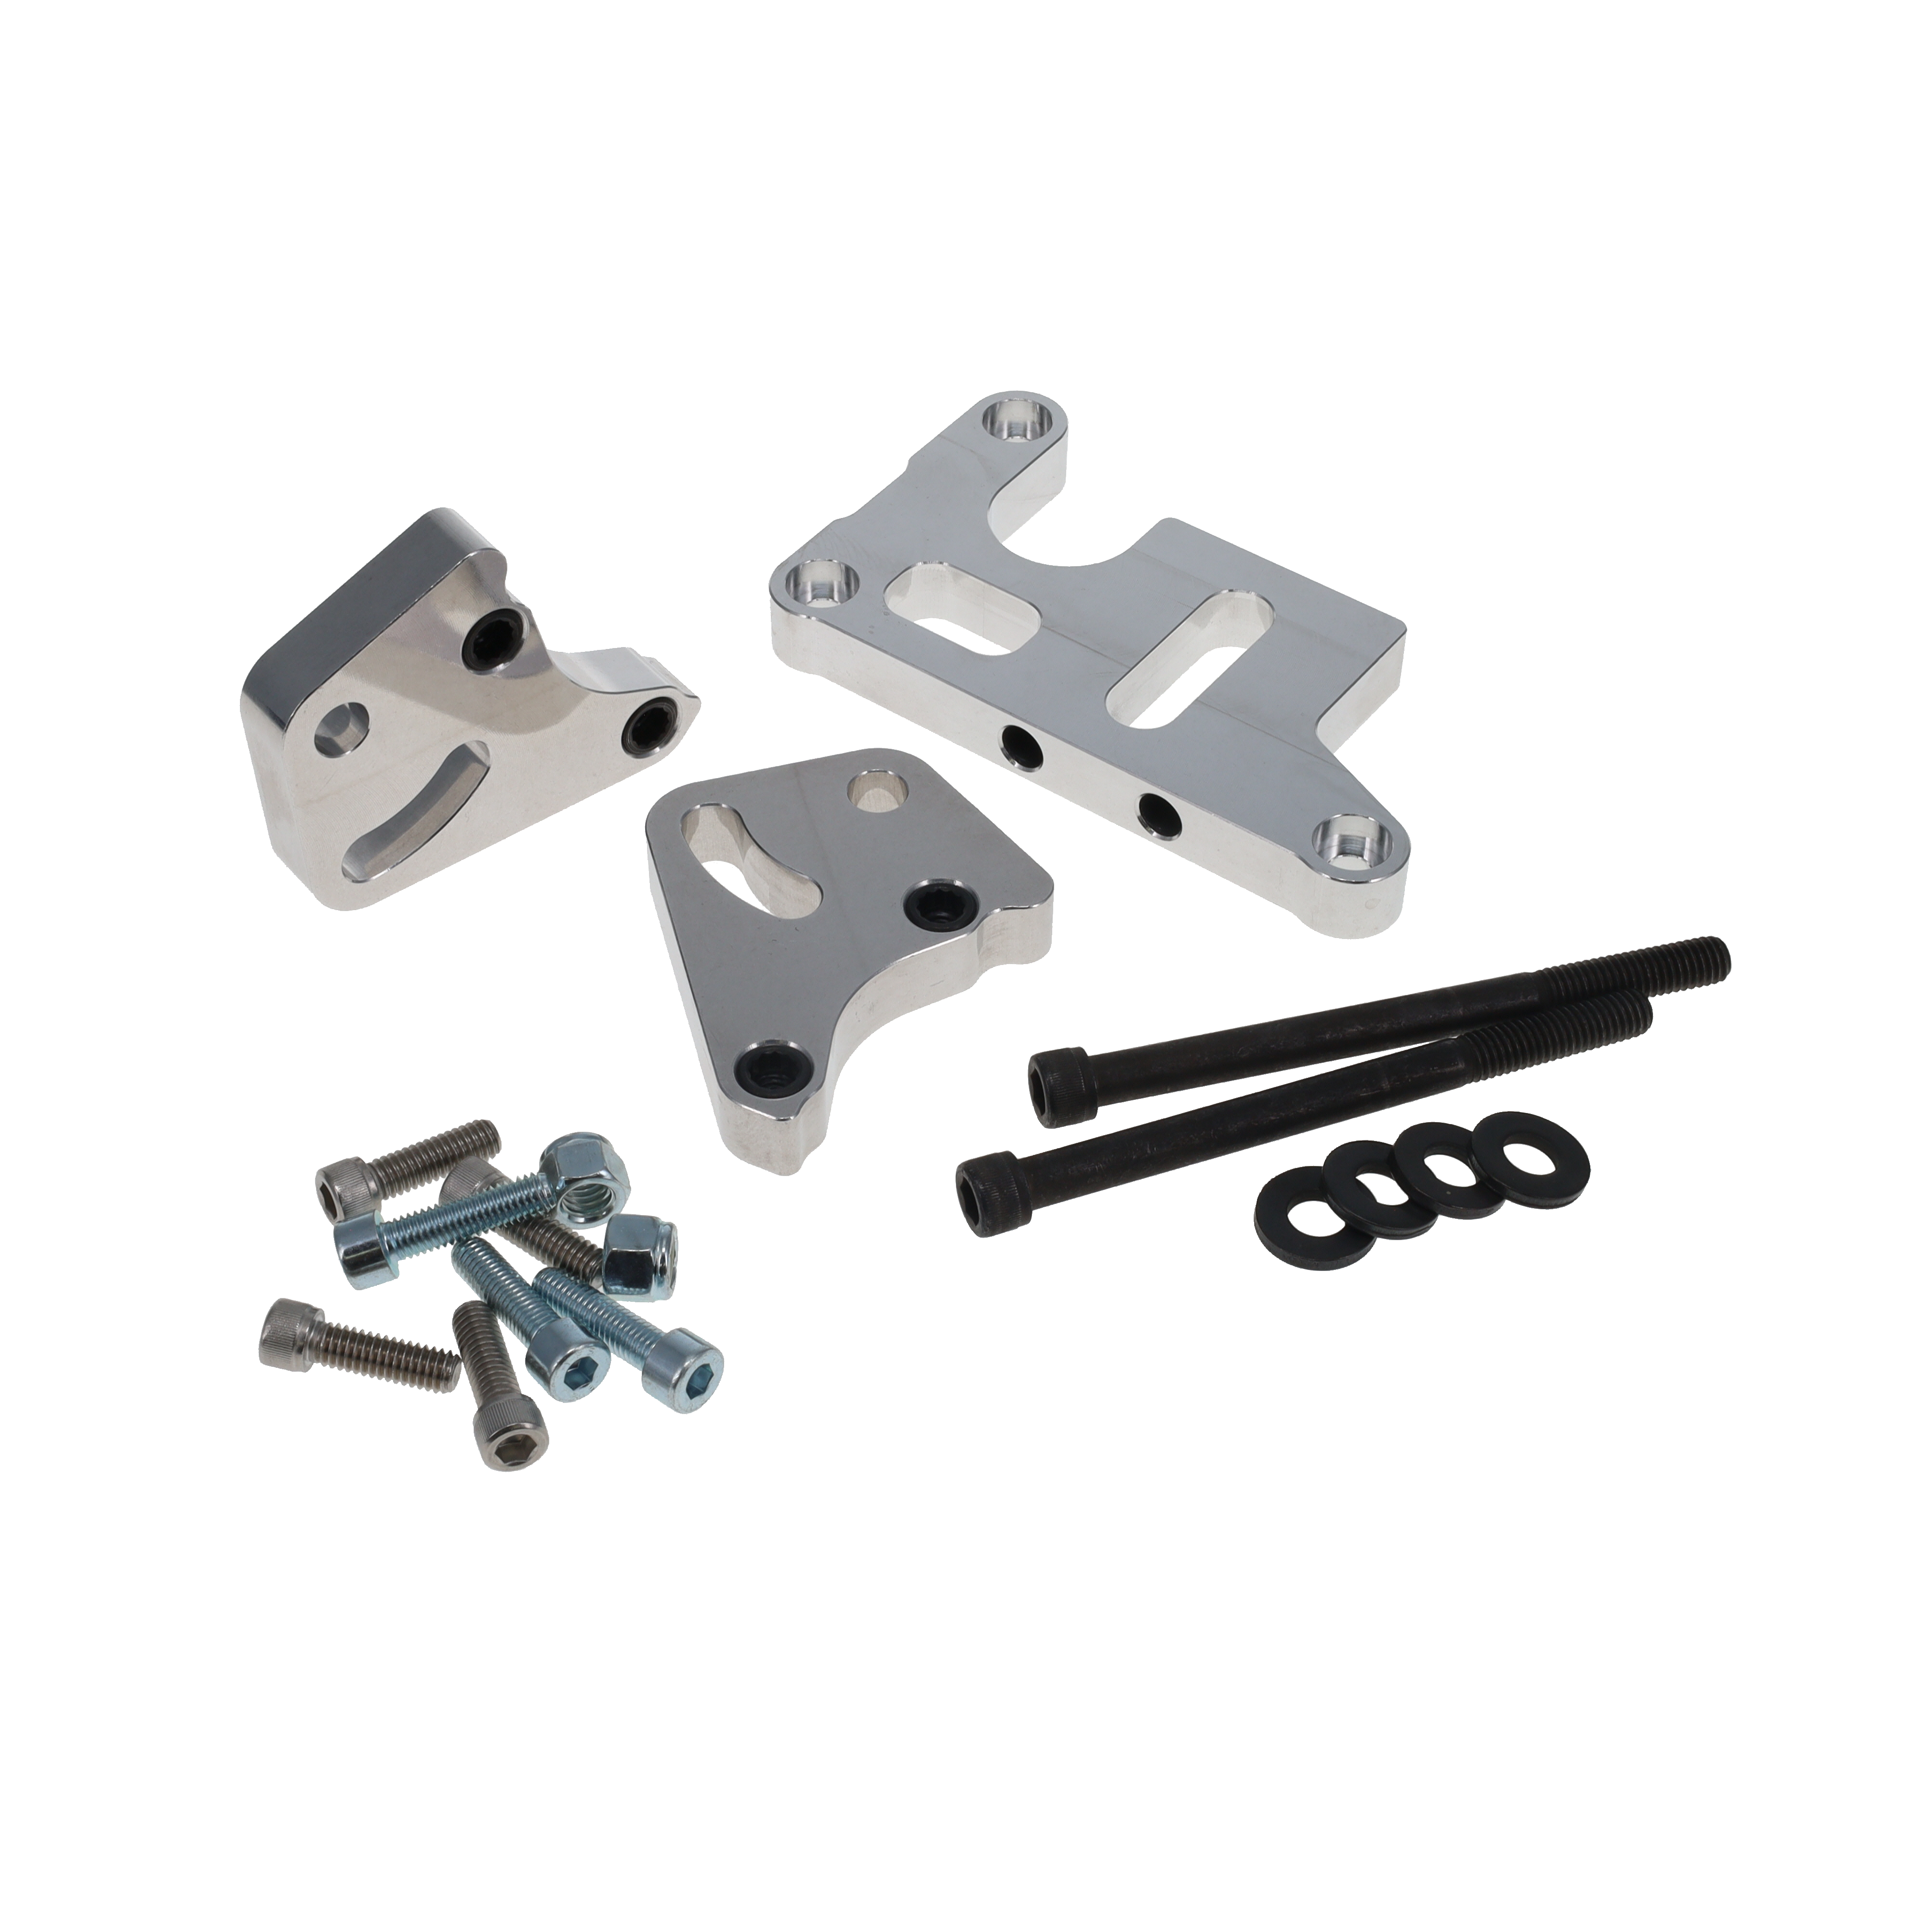

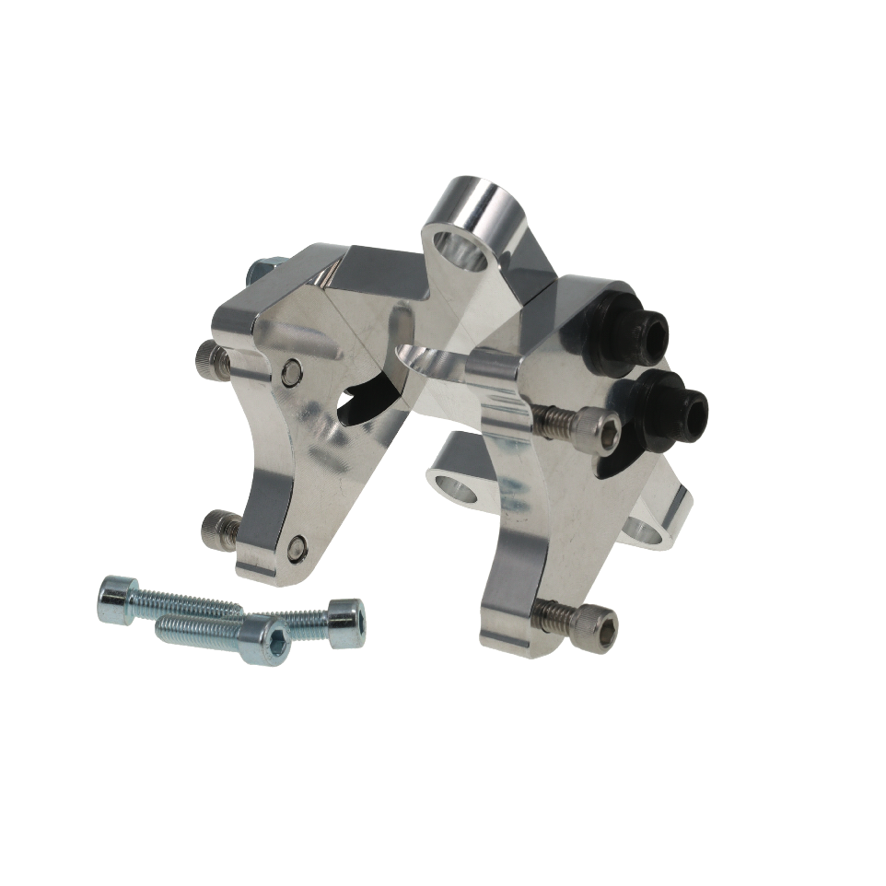

|  |
| --- |
| **Pricing** |
| **For current pricing contact Peterson Fluids Systems at**[**pfsinfo@specprod.com**](mailto:pfsinfo@specprod.com)**or 800-929-7867** |

**14-3112**

All pricing in US Dollars • ©2024 Niwot Corp. dba Specialty Products Company®

*4045 Specialty Place • Longmont, CO 80504 • 800-929-7867 • 303-287-1731 • www.petersonfluidsys.com*

**SSAVE OVER**

50%