##### 747 ­

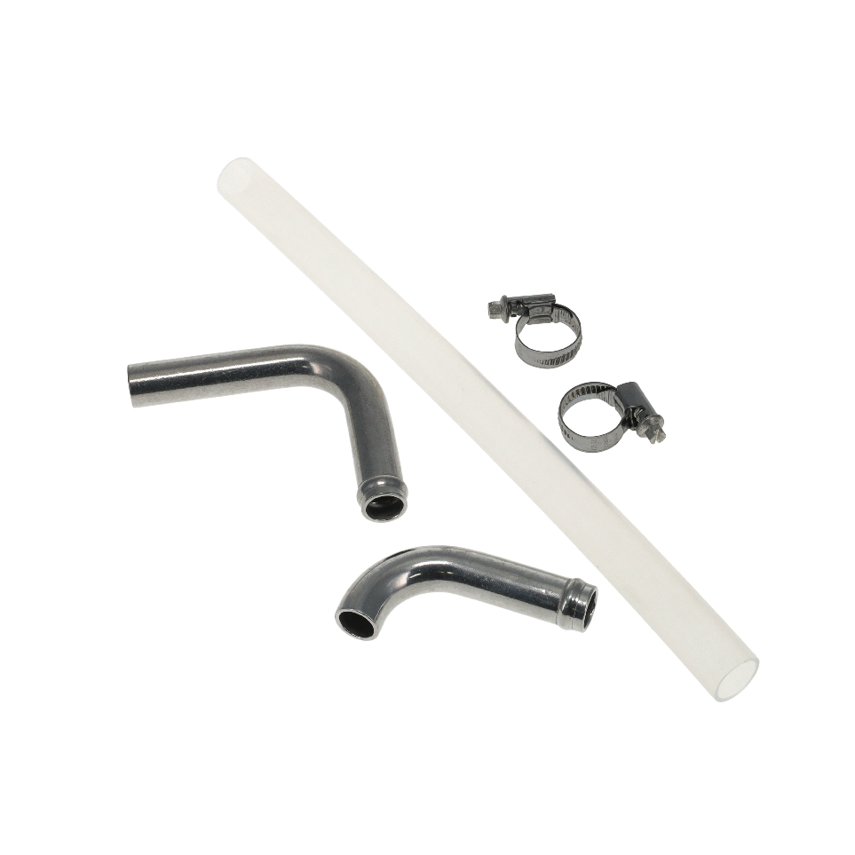

March 30, 2023

Press Release/New Product

**UNIVERSAL SIGHT TUBE KIT**

**Part No. 18-2000**

Check your oil level at a glance!

Peterson's Universal sight tube kit allows just that and is perfect for marine applications or other vehicles where a dry sump tank is difficult to check with a dipstick. Fabrication is required, kit Includes 2 weld in aluminum tube bends, 12" of Teflon® tube and 2 hose clamps. Made in the USA since 1976, Peterson Fluid Systems continues to lead the industry through innovation.

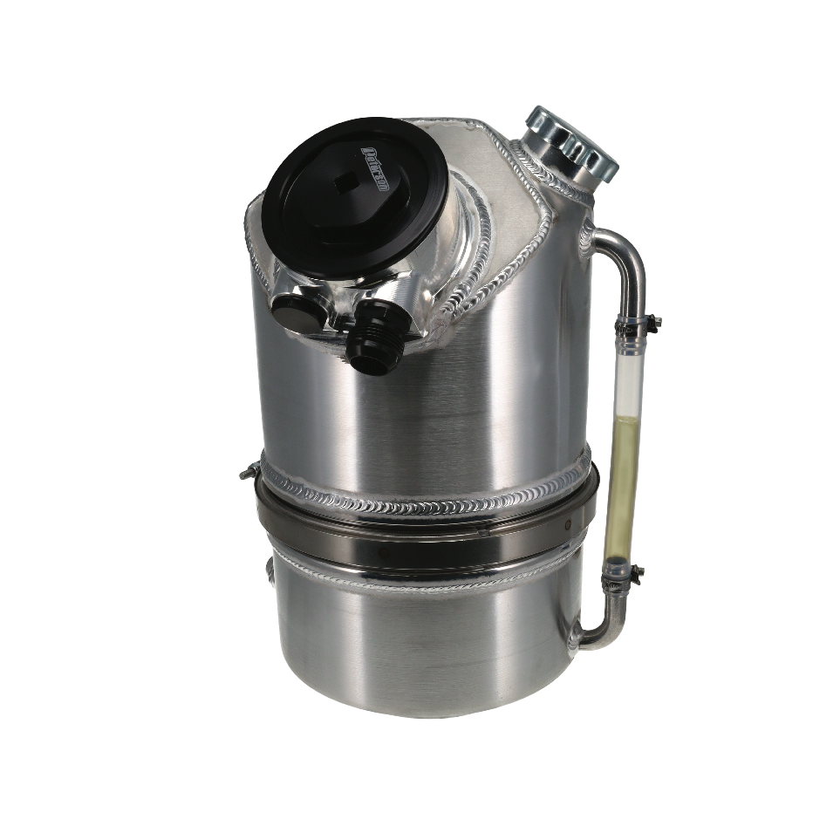

|  |  |  |
| --- | --- | --- |
| **Part #** | **Racer** | **List** |
| **18-2000** | **84.65** | **105.81** |

All pricing in US Dollars • ©2023 Niwot Corp. dba Specialty Products Company®

*4045 Specialty Place • Longmont, CO 80504 • 800-929-7867 • 303-287-1731 • www.petersonfluidsys.com*

**SSAVE OVER**

50%